**PUmped Liquid System for Amateur Rockets**

Project PikaPump



Critical Design Review

Submitted to:

Professor David Cappelleri

Authored by:

James Beeman, Lamya Bhat, John Clark, Max Cohen, Fred Gou

Date:

March 5th, 2024

**Table of Contents**

| **Executive Summary** | 3 |
| --- | --- |
| **Main Body** | 5 |
| **Appendix 1 - Project Management** | 14 |
| 1. Project Charter | 14 |
| 1. Schedule | 14 |
| 1. Budget | 16 |
| 1. Risk Register | 16 |
| **Appendix 2 - Business/Marketing** | 19 |
| 1. Market Analysis | 19 |
| 1. Value Proposition | 22 |
| **Appendix 3 - Design Process** | 24 |
| 1. Engineering Requirements and Constraints | 24 |
| 1. CAD | 25 |
| 1. Analysis | 30 |
| 1. FMEA | 40 |
| 1. BOM and Sourcing Plan - James, John | 43 |
| 1. Validation Plan - Lamya, fred | 45 |
| **Appendix 4 - Works Cited** | 49 |

**Executive Summary**

This report is a summary of the work completed by PULSAR to create project PikaPump. PikaPump is an electric fuel pump created for amateur rocketry. To create an efficient, safe, and cost-effective pump, the team began with analyzing existing commercial fuel pumps to understand their working principle and the design of each component. Having completed the market analysis and project overview the team began to integrate design components while prioritizing efficiency. The team used different software to model and test finalized designs and went on to finalize a BOM as well as a final validation plan as a part of the critical design phase.

The team verified design goals and parameters using hand calculations and then went on to use tools such as CFTurbo, Ansys and OnShape to design and verify design functionality and evaluate if the design met target values. Once satisfied with the calculations, the team used CFTurbo and CFD to model the pump flow. During this phase the team worked to better understand the causes of cavitation, and benefits of using an axial inducer. As the team learned to use and explore the capabilities of both tools, design flaws became obvious and were addressed systematically. The team went on to model the design in CAD using OnShape and moved toward other design components and the BOM.

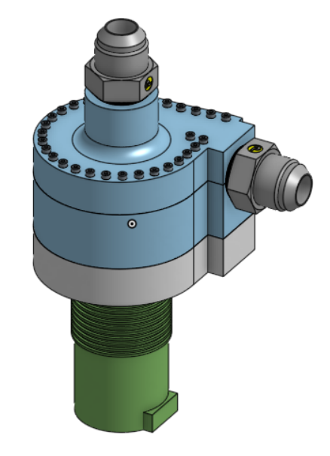

**Figure 01**:CAD model of Pump System.

The next important design component was the magnetic coupler. The team researched the benefits of buying versus making a magnetic coupler and chose the latter due to budget constraints. A coaxial design was chosen to allow for maximum torque and RPM. The team went on to model the magnet carriers in CAD and finalized a pump design that accounted for shaft, magnetic couplers as well as bearings to stabilize the central axel and prevent shifting. Simultaneously the team also worked on the design of the control system which will communicate information to the motor and collect test data from multiple sensors. The team chose an Arduino for Data acquisition and system monitoring since it allows analog and digital inputs from the different sensors. The Arduino connected to a laptop and sensors allows in real-time display of different measured variables and can trigger automatic emergency shutoff if needed.

Lastly, the team worked on planning for data acquisition during the testing phase. The team created a model for the test setup and modeled sensor placements as well as brainstormed how to measure final pump performance.

In conclusion, the development of PULSAR exemplifies a comprehensive approach to designing and testing a fuel pump for amateur rocketry. Through meticulous analysis, integration of design components, and utilization of advanced software, the team successfully achieved the project's objectives of enhancing efficiency, safety, and cost-effectiveness. The selection of the magnetic coupler design and the implementation of electronic systems further underscore the project's commitment to innovation and performance. Ultimately, PULSAR represents a significant advancement in the field of amateur rocketry, offering a reliable and efficient solution for fuel pumping systems.

**Main Body**

Since humanity landed a man on the moon in 1969 we have been obsessed with launching people, and things, into space. Purdue is a perfect example of that, having the nickname “The Cradle of Astronauts” and housing the Purdue Space Program (PSP), one of the largest student rocketry teams in the United States. One of the most difficult aspects to design of those rockets is how they are propelled into space. It has been found recently by companies like Rocket Lab that electric pump-fed systems are very efficient at moving rocket fuel from the tank into the combustion chamber. These electric pump feed systems provide many benefits over traditional rocket fuel systems like less chance of failure, higher efficiency, and easier manufacturing. Despite these revolutionary new findings, very little progress has been made towards creating a similar system for amateur rockets.

PUmped Liquid System for Amateur Rockets (PULSAR) aims to bridge this gap between commercial rocketry and amateur rocketry spaces. Some of the members of the team were formerly on the PSP team and have experience developing amateur rockets. After seeing the potential that electric pump feed systems have in the amateur space, the team was disappointed to find that there have been very few attempts to create this fuel feed system for an amateur rocket. With this, the team saw an opportunity to create a large amount of value for amateur rocketry by using their expertise. The team decided on the goal of furthering the knowledge of liquid amateur rocketry by designing, analyzing, and then creating an electric pump feed system for rocket fuel on an amateur scale.

PULSAR’s preliminary design phase saw the team create an initial project scope, analyze the market for existing products(Appendix E), create customer requirements based on the market(Appendix G), create concepts for those requirements, and finally select a final design idea for the critical design phase. The team was satisfied with where the project was headed after the preliminary design review. The structure of team management had worked well and those areas of the projects remained largely unchanged(Appendix 1). Figure 02 shows the initial concept sketch that the team planned to refine moving into the critical design phase. There were some additional considerations into what the team would deliver for the unique value proposition (Appendix F) along with some deliberation into which specific aspects of the project to focus the design more heavily on. The team did think the initial prototyping ideas were still valuable so the design began there while the overall project was being analyzed with an FMEA.

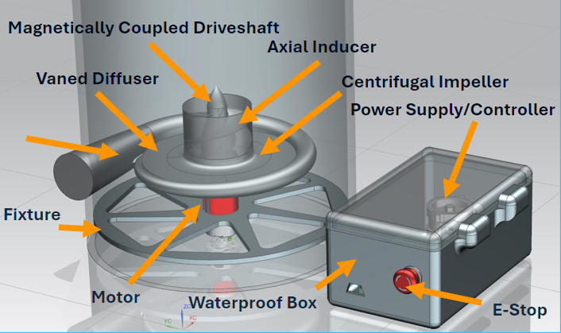

**Figure 02**: Concept sketch at the end of PDR

To begin the critical design phase a failure mode and analysis was performed to identify the aspects of the project that would need the most attention through the critical design phase. The FMEA (Appendix J) was a collaboration by all team members. The team decided that identifying where the pump could possibly fail right away would allow for ample time to design for mitigation of those failure modes. Upon completion of the FMEA the team could clearly see which aspects of the design needed the most attention. The primary two are the pump impeller and the materials and clearances of the housing. The team decided to start there for both the design and the preliminary prototypes.

To begin the pump design the team turned to textbooks on centrifugal pump design to figure out what needed to be calculated in order to design a functional pump impeller and inducer. The calculations began by taking the operating conditions of a 200 psi pressure rise at a mass flow rate of 1.19 lbm/s at the outlet and using those to get estimations on NPSH, NPSHA, and specific speed of the pump. For those calculations an rpm value was chosen based on pumps with similar operating conditions. Having all the main parameters of the pump a pump type could be chosen and then CFTurbo was able to assist in the design of many specific aspects of the pump geometry. By giving CFTurbo the requirements and operating conditions of the pump it is able to assist in creating geometry. CFTurbo is a CAE tool which uses empirical estimates and its own proprietary formulas to help in the conceptual design of pump geometries. It does calculations to produce a base design that can then be modified by the team. Different parameters like blade shape, blade angle, amount of blades, and the overall dimensions of the impeller were changed by the team, as CFturbo’s default values for these options were not manufacturable. For the rest of the design, the team used the default settings as that was the simplest and least time consuming method. As shown later in the report this hybrid of the default and custom designs provided a satisfactory final design which met or exceeded the requirements.

A pump such as this one requires compatibility with cryogenic fluids as low as 80K. At those temperatures, a considerable amount of thought goes into the material selection for the whole design. Some materials (mostly steel) turn brittle at cold temperatures because their yield strength increases at lower temperatures while their fracture strength doesn’t change much with temperature. The temperature at which yield strength exceeds fracture strength is called the ductile-brittle transition temperature. At this temperature, fracture becomes the primary failure mode for the material. Although the strength of the material has not dropped at all, the toughness will go down significantly because there is no room for any plastic deformation, meaning less energy can be absorbed before failure. The goal is to choose a very low DBTT when selecting materials. Aluminum is an excellent choice, as it does not have a DBTT. Strength and toughness remain constant (or even increase in certain alloys). The only disadvantage is that aluminum experiences non-uniform elongation at low temperatures. The team ended up choosing aluminum due to its low cost, low weight, machinability, and satisfactory cryogenic properties.

After finishing some initial design calculations the team decided to create two different prototypes in order to attain a better understanding of the final product. The two prototypes were a 3D printed impeller with very similar geometry to the actual final impeller that will be used and a roughly machined simple impeller to test material tolerances and rotation. Photos of the prototypes can be seen in figures 03 and 04.

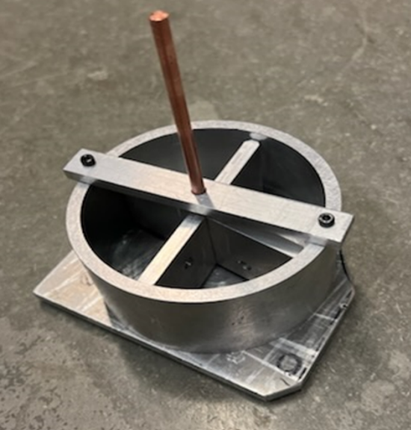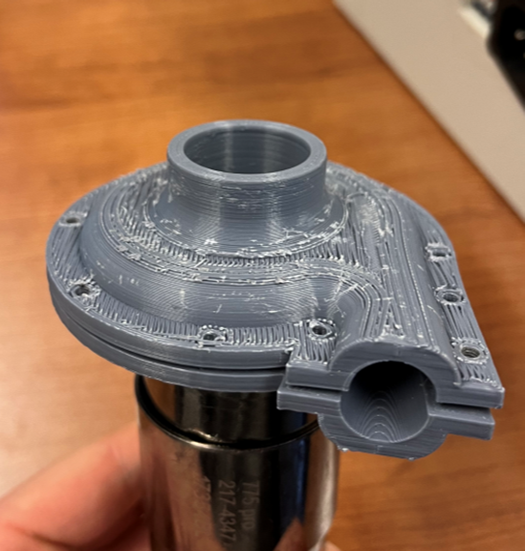

**Figures 03 and 04**: Material tolerancing prototype (left) and accurate impeller prototype (right)

These prototypes both performed as expected providing valuable design insights for the team. The 3D printed impeller gave the team a better understanding of how the final project will look as well as provided info about 3D printing clearances and sealing on the housing. The rough machined fin served to verify material tolerance calculations and to confirm that the materials chosen would be able to rotate effectively under very cold temperatures.

While the initial prototypes were being created and analyzed some members of the team were also working on performing CAE analysis on the project. More specifically, a CFD simulation of the pump impeller using the cryogenic fuel that it was being designed for (Appendix I). The team first took the geometry created with the assistance of CFTurbo and put each part as a separate domain into Ansys workbench. The team meshed each part according with a mix of inflation meshes to account for boundary layers and standard size meshes elsewhere to improve performance of the simulation. After each part was meshed the meshes were inputted into Ansys’ CFX for the simulation. In CFX-Pre the inlet, outlet, boundary, and interface conditions were all applied in order for the simulation to accurately match how the pump will function in reality. After the simulation had been solved the team analyzed the results. It was recognized that the pressure at the outlet region was not high enough with the initial design to meet the requirements. In order to meet this requirement a backflow region was designed in the impeller in order to increase the pressure at the outlet. Another simulation was run on the updated design and it was found the design not only met but far exceeded the pressure outlet required by the pump. Figure 05 shows these results. It can be seen that the pressure at the outlet is around 1.87e06 Pa which is around 275 psi, 35 psi higher than the engineering requirement. Based on these results the team was satisfied moving forward with this pump design and moved forward onto further design aspects.

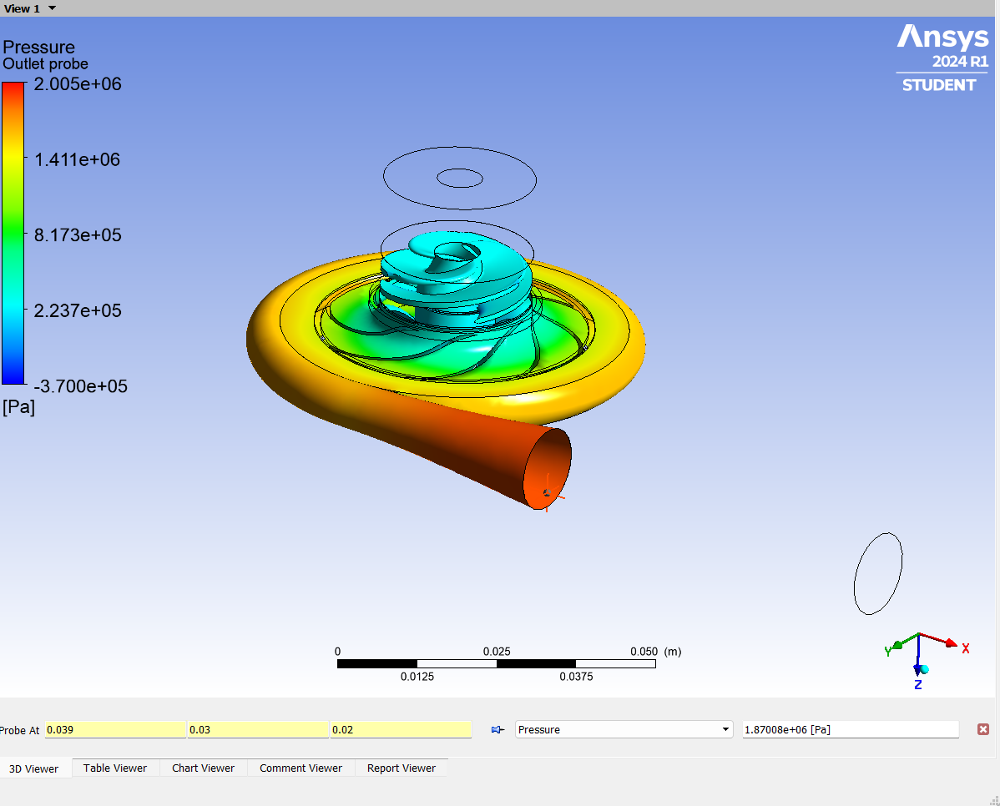

**Figure 05**: Pressure results from final CFD simulation

From the CFTurbo power requirements from the motor could be taken. It was found that the motor would need to provide 3000 watts of power to move the fluid at 35000 rpms. The team found a motor from castle creations that can provide up to 3600 Watts of power and has a maximum rpms of 56000. This motor fits the specifications required for the pump and is within the budget of the project. There were not many other viable motor options. The alternatives either did not have enough rpms, did not have enough power, or were too expensive so this was a straightforward choice for the motor and controller configuration. To power this motor the team plans to use a 65V lithium ion battery which will be purchased.

One of the team’s more novel design choices is to use magnetic coupling to drive the pump impeller. This removes the need for a dynamic seal, which has always been a problem with this project for previous benchmarks. A magnetic coupler can be purchased online. These will come as a set of parallel discs filled with magnets, and by aligning them and rotating one, there will be an effective magnetic torque that drives the other. Very few options were small enough for our design and none were powerful enough, so the team decided to build the couplers in-house simply by housing neodymium magnets in a ring, alternating the direction of polarity. These will be made using a disc rotor from a BLDC motor and machined aluminum parts.

Another component of critical design is the housing and sealing of the pump. The impeller and volute geometry were imported from CFTurbo and a 2-piece housing was designed to surround the impeller using the same tolerancing scheme as used for the preliminary pump prototype (.01” clearance). A ridge will be left along the mating surface of one side of the housing (and a matching channel carved into the other) so that the two halves will always connect the exact same way. See figure 06 below for a side section view of the impeller, axial inducer, and aligning ridge/channel notches along the sides. These aligning notches also serve to compress the sealing gasket, which seals better at cryogenic temperatures when compressed by corners.

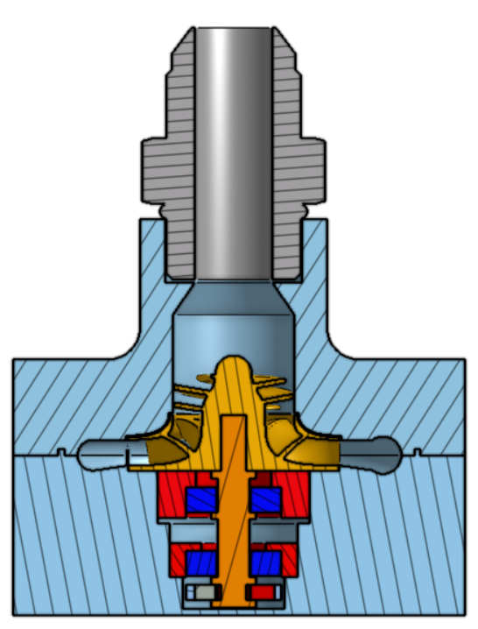

**Figure 06**: Section view of the pump and with the impeller and axial inducer highlighted in yellow, bearings in blue, bearing blocks in red, shaft in orange, fitting and magnets in gray, and housings in blue.

After PDR, the team began to worry that too few fasteners holding the pump housing together would cause leakage due to the massive pressure inside the pump inducing elongation in the bolts. Also, as discussed previously, carbon or nickel-less steel bolts may be brittle if they get too cold. Therefore, the team decided that a bolt elongation of any more than .0001” was unacceptable and calculated how many M2.5 stainless steel bolts would be needed to hold the pump housing together. Utilizing bolt tensile area, the bolt elongation formula, and stress/strain relationships, the team calculated that 30 bolts will be needed on the pump housing.

An additional concern was that the .8185 Nm of torque applied to the aluminum driveshaft would be too much. The minimum shaft diameter was calculated using AA6061 properties and torsional-shear stress relationships, resulting in a minimum diameter of .107” (.193” with a safety factor of 1.8). Satisfied with this calculation, the team created the pump design with a shaft diameter that doesn’t drop below .2”. See Appendix I for more detailed calculations regarding shaft torque and bolt numbers.

After having designed all of the separate components of the pump a test plan was created to validate the design phase. Due to time, money, and safety constraints the team will not be testing the pump with the cryogenic liquid methane and instead just using water. The test setup can be seen in figure 07.

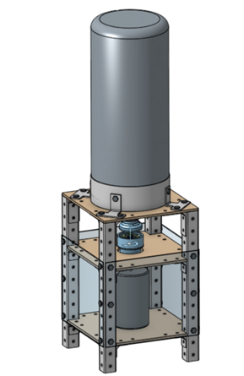

**Figure 07**: CAD Model of Pump Test System

This test will qualitatively analyze many of the differently designed components. The motor, sealing, coupling, and fasteners will be analyzed to determine whether they function as intended. To understand further the quantitative results that are to be expected from the test plan a CFD simulation with the same setup was run, but with water instead of liquid methane. This will allow the team to more accurately predict what the quantitative results from the final experiment will be (Appendix L). A cavitation analysis with water was also performed to ensure the pump would not cavitate during the test. If the pump performs similarly to how it performs in the CFD analysis the team will consider the experiment a success.

Throughout the process of analyzing different components of the pump and while creating the test plan a bill of materials was being kept. As the analysis reached a close a more accurate complete picture of everything needed for the project was attained, and with that a final bill of materials and budget could be created (Appendices C & K). The primary expenses will be the motor and controller, which is to be expected due to very stringent power, speed, and weight requirements. Additionally, cryogenic-compatible bearings, a battery, and 3D-printed steel will drive up the cost. Many parts such as the housing components will be machined in the ME Student Project Machine Shop or the M&M Lab with the CNC mills and lathes.

After completing the different design aspects, PULSAR has gained the necessary knowledge to create a functional electrically powered liquid feed system for amateur rocket applications. The team learned that a backflow region was necessary for the pump to reach the required operating conditions. After the pump design was complete the team learned a much more powerful motor was required than originally expected so additional time had to be allotted to properly selecting a motor that could fulfill the requirements. The team learned that creating a magnetic coupler would be easier than expected and would be much cheaper to manufacture in-house than to purchase a custom one. All of these discoveries along with other smaller ones relating to other various design aspects have put the team in a position to succeed.

Moving forward the team plans to begin as soon as possible the creation of the pump and the final test setup. With the finished bill of materials, the team plans to begin ordering parts as soon as the critical design review is approved. Upon receiving the materials, some of the team will begin to machine and assemble the parts for the pump as necessary. While that is happening other members of the team will begin the creation of the test stand and calibration of the data acquisition systems. On top of that additional CFD simulations will be run to create additional materials like a pump curve for this design and alternate designs for the design manual as part of the final deliverable for the value proposal.

PULSAR came into CDR with a final concept selected and a general idea of where to go with the analysis. The team performed an FMEA to further direct what functions the analysis should occur. Preliminary analysis of the pump and materials was performed. Upon completion of the initial analysis, simulations, and prototypes were created to verify the results of those analyses. With the additional information from the prototypes and simulations the team finished the design of the rest of the necessary concepts and now has a final design for the PikaPump. Using that final test plan PULSAR created a validation plan to confirm the function of the pump upon manufacturing. The team believes it has attained all the knowledge necessary to move forward from critical design and onto the manufacturing and test phase.

**Appendix 1 - Project Management**

**A. Charter**

One of the first documents created was the team charter. Here, the vision statement is outlined, along with a problem definition, scope of work, assumptions and risks, key milestones, stakeholders, public benefit, resources required, and member roles (listed below in Table 01). This document guides the direction that the team will follow throughout the semester and serves as a reference that can be used to keep the design on track. The full team charter can be found attached to this report as an excel file, but the key takeaway can be summarized with the team’s vision statement: “*To further the research and development of liquid feed systems primarily for the amateur rocketry space*”. The Charter has remained unchanged throughout the second phase of this project. The team deemed the original goal attainable and will continue forward with the existing document.

**Table 01:** Team Members and Primary Project Roles

| James Beeman | Manufacturing Manager |
| --- | --- |
| Lamya Bhat | Power Systems Lead |
| John Clark | Purchasing Manager and CFD Lead |
| Max Cohen | Project Manager and CAD Lead |
| Fred Gouronc | Chief Engineer |
| Tom Neidlein | Testing Procedures Lead |

**B. Schedule**

The schedule that was created previously with Microsoft Project continued to be utilized to guide the team toward accomplishing the set out goals. The core layout and plan remained relatively unchanged, with exception of minor fluctuating deadlines both within the team and changes to the ME 463 course schedule. Both the PDR and CDR phases have been completed, save for the finalizing of the manufacturing drawings. This is expected to be finished by March 10th at the latest. Excerpts of both the CDR and FDR phases are shown in Table 02. below, with a new copy of the full updated schedule available in the attached Microsoft Project file.

**Table 02:** CDR and FDR Phases of Project Schedule

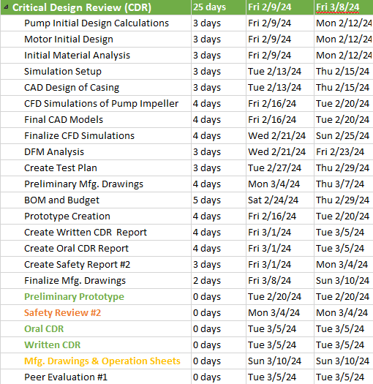

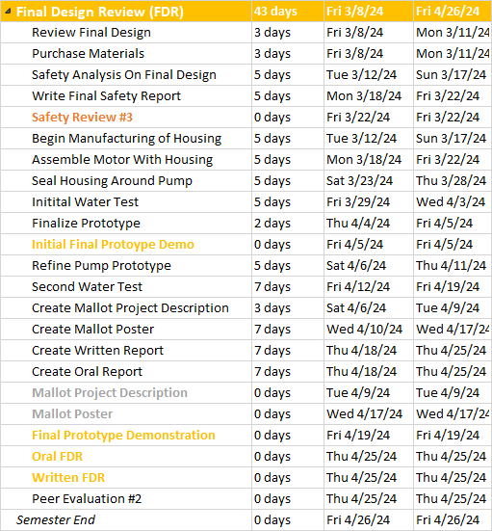

**C. Preliminary Budget**

Using the updated bill of materials (BOM) a final budget was created for the project. It can be seen that the majority of the budget goes to motor, the pump impeller, and the power supply. Figure 08 shows a detailed breakdown of all individual components to be purchased.

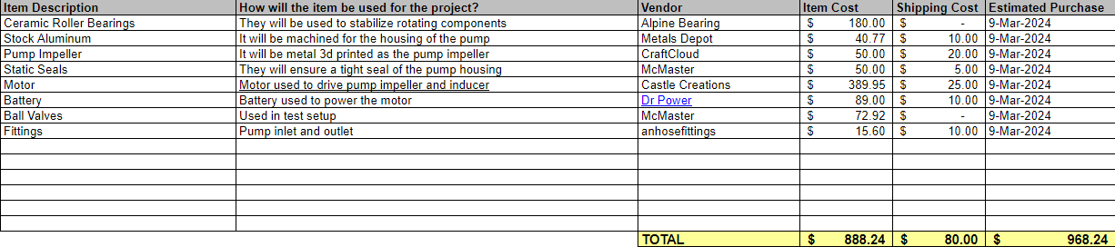

**Figure 08:** Preliminary budget for the PikaPump project.

Currently the budget is slightly under the $1,000 limit for the team. This was deemed satisfactory as there will likely be unexpected expenses and this surplus will help to mitigate that risk.

**D. Risk Register**

In order to analyze and plan ahead for the risks on the project a risk register was created. This document records the source of the risk, the cause, effect, and risk score for many sources of risk on the project. Figure 09 shows the risk registers identification section. 12 sources of risk were identified for this preliminary analysis. The most urgent being the ability of the motor to operate effectively, the pump cavitation, and the test causing harm to a member of the team.

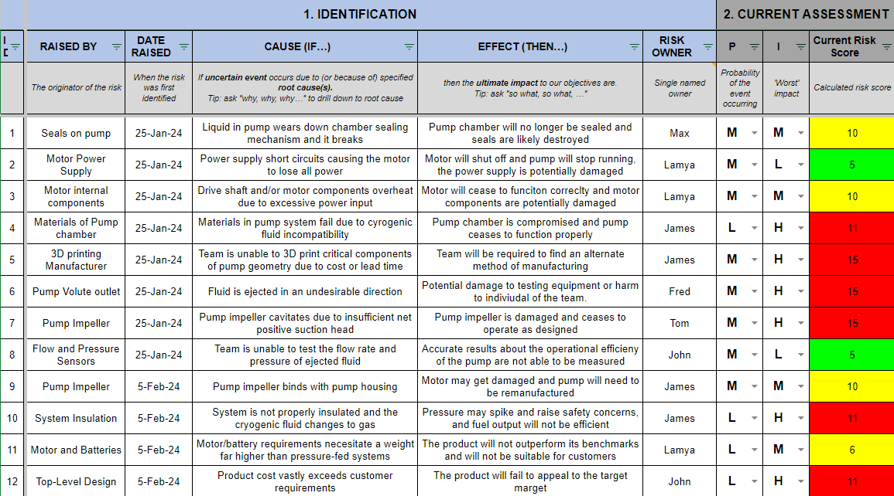

**Figure 09:** Identification section of the PikaPump risk register.

For each identified risk the team decided to either accept or mitigate that risk. Based on that decision a treatment strategy was created for each risk that will be implemented by the responsible team member. The risks were then reanalyzed for their residual risk score after the treatment. The treatment section of the risk register can be seen in Figure 10.

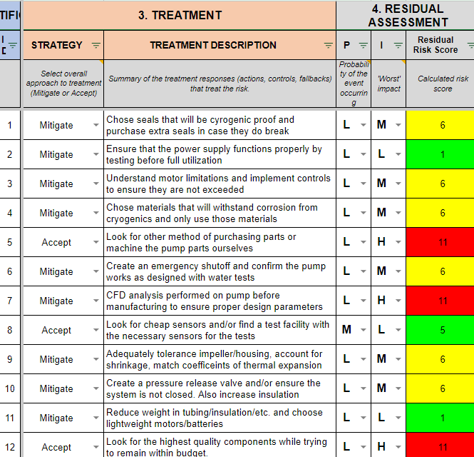

**Figure 10:** Treatment section of the PikaPump risk register.

The actions taken during this stage of the project were to review some of the risks and analyze how well the fixes have worked. Figure 11 shows the review control and communicate section of the risk register. Currently there have only been some risks directly addressed as most of the risks will begin to arise in the testing portion of the project.

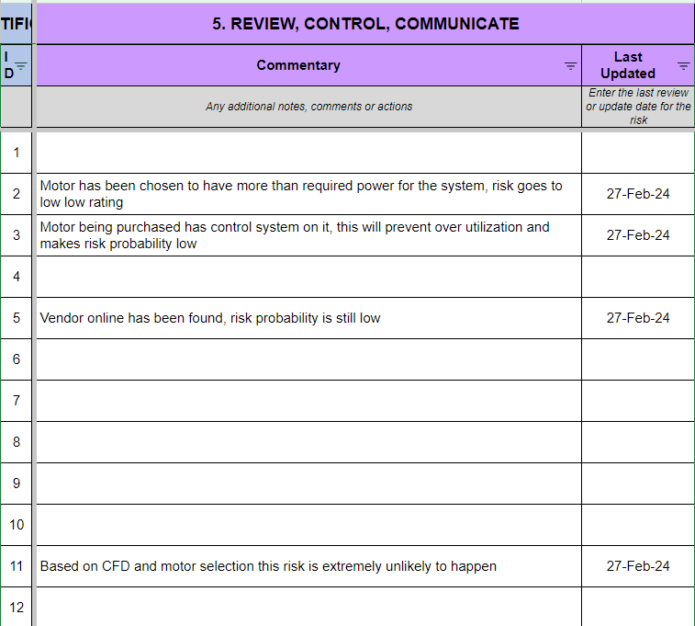

**Figure 11:** Review, Control, Communicate section of the PikaPump risk register.

This document will continue to be updated as the project continues in order to ensure that the team is recognizing potential risks for the project. It also ensures the team is taking the proper steps to ensure these risks don’t happen, or if they do happen the team knows how to deal with the consequences. Currently the team believes all risks have been identified and mitigated appropriately.

**Appendix 2 - Business/Marketing**

**E. Market Analysis**

A market analysis was conducted to study the feasibility of meeting the goals outlined by the team. Major factors included both identifying target customers for the design and their specific needs, as well as finding potential competitors or patents that might preclude further development of the design. Data from existing non-electric rocket pump designs was also used as both a reference and point of comparison, due to the limited amount of resources available in this market due to it being a relatively niche product.

Patent research was conducted primarily through the online Patent Public Search database of the United States Patent and Trademark Office (USPTO), to identify any patents that may cover the proposed electric pump fed system design. This revealed that several such designs do exist, with a majority being held by the U.S. aerospace company Rocket Lab. These primarily deal with the design, control systems and integrated propulsion of the Rutherford engine, an electric turbopump-driven rocket engine, used on Rocket Lab’s Electron launch vehicle. A picture of the Rutherford engine is shown in Figure 12, and a simplified diagram of its turbopump is shown in Figure 13. Despite this, the pumps used on the Rutherford engine differ from the proposed design in two key areas. They are much larger being intended for commercial use, and are turbopumps, meaning that they rely on the combustion gasses produced by the engine for power. Being that the proposed design is intended for amateur use and relies solely on electric power to drive the pump, we believe that it falls outside the scope covered by these patents.

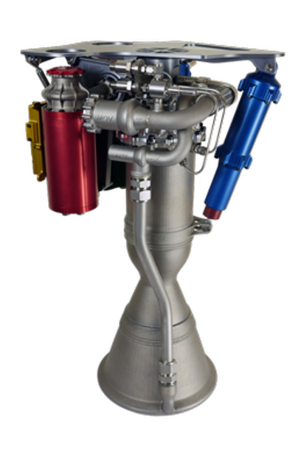

**Figure 12:** Rocket Labs Rutherford Electric Turbopump-Driven Engine

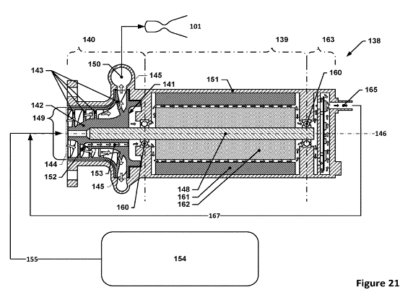

**Figure 13:** Simplified Diagram of Rocket Labs Electrically-Driven Turbopump

After extensive market research, it was found that there are no existing designs currently available for sale in the amateaur and hobbyist market for electric pump fed systems. However, several different groups and organizations have produced their own unique electric pump fed designs. The Portland State Aerospace society, based at Portland State University, created a dual electric pump system for use in their own bi-propellent rocket. A picture of this completed pump is shown in Figure 14. However, this design suffered from a lack of engineering analysis, and no qualitative data was collected from the testing. This would make it difficult to verify the performance of this design, limiting the ease of replication or potential use as a base template for other designs. Another group at San Diego State University created a similar design, and conducted significantly more fluid engineering analysis in the design creation. A picture of this completed pump is shown in Figure 15. Despite this, there were still notable flaws, as the design was not intended to work with cryogenic fuel, and suffered notable leakage during testing, a major potential safety hazard. As a result of this leakage, the system also failed to meet projected performance targets. While both pump projects offered valuable insight into the design of electric pump feed systems, ultimately neither were sufficient in producing a viable design that could be further marketed or sold.

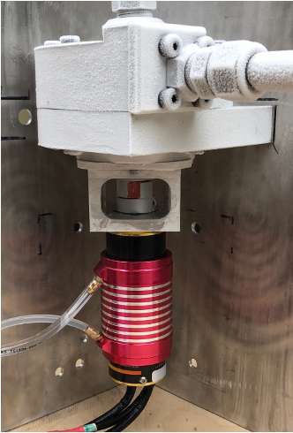

**Figure 14:** Portland State Aerospace Society Electric Pump Feed System

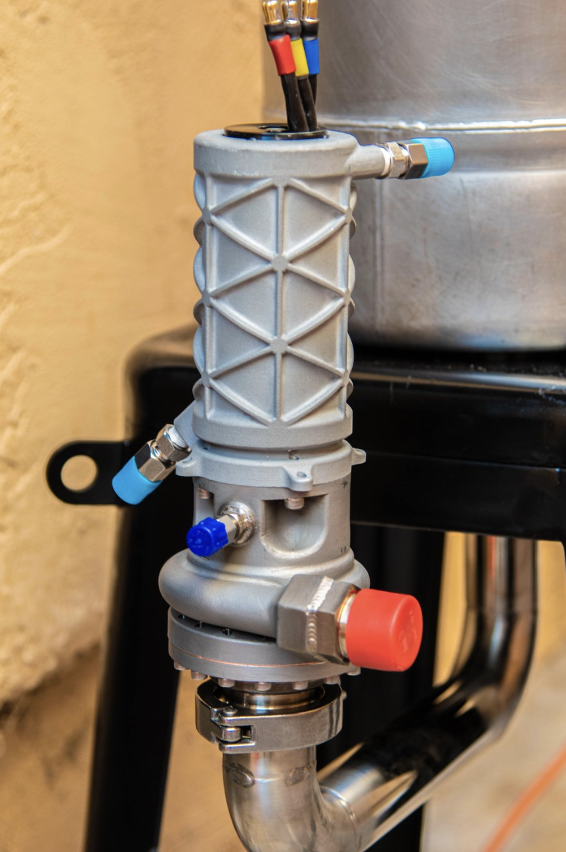

**Figure 15:** San Diego State Electric Centrifugal Pump

Due to the aforementioned shortcomings of existing resources, and to provide further insight into design requirements, Purdue Space Program (PSP) was contacted and provided data from their existing pressure-fed rocket propulsion system. This allowed the team to have a set of verifiable benchmark performance metrics to use as a baseline target when designing the electrically-driven pump.

The market analysis has remained unchanged as no additional information was uncovered during the critical design phase. The team believes that the continued application of the proposed design will be providing new and beneficial value not yet captured by any product currently on the market.

**F. Value Proposition**

This project appeals to a very niche market of around 75 liquid rocket teams, totalling less than a thousand people in the United States. This market would not support an engineering company focused solely on electric pumps. Additionally, the average hobbyist and student rocketeer is someone who relishes the opportunity to solve their own problems, build their own custom hardware, and is driven to innovate. Therefore, PULSAR aims to provide these individuals not with a pre-built solution, but with a roadmap that assists them as they traverse through the complex design space that is an electrically pumped feed system. This roadmap would be provided for free to individuals, and consist of a repository of all the work done by the team and a handbook of recommendations for individual’s projects. Despite a lack of a conventional business case, this project would still provide societal value.

As stated previously, industry launch vehicles utilize primarily pumped liquid systems, and by assisting amateur and student teams, individuals can develop their skills and train themselves to more easily pursue a career working in the space industry. Assuming that 100 professionals graduate each year from one of these organizations, each utilizing knowledge attained from PULSAR’s roadmap, they would have an economic impact of tens of millions of dollars simply due to their salaries and their impact on the 3.5 billion dollar space launch market.

The value proposition has remained largely unchanged, besides the team deciding on how to deliver this knowledge to the stakeholders. The team will plan on providing a design guide as an open source tool for anyone interested to use. In this design book all design considerations will be explained along with tips on how the user could proceed with their own design. The team believes that by providing this as an open source tool users will be able to take the knowledge gained by the team and use it for their own design as well as further, more in depth design, using this as a base for their project.

**Appendix 3 - Design Process**

**G. Engineering Requirements and Constraints**

To establish a benchmark of success the team then worked on creating engineering requirements and constraints. The goal here was to cross-reference the requirements against the specifications to check which need to be met to fulfill a customer's need being met. The team then worked to compare and understand the current competition. The team created benchmarks based on how current products meet the team's customer requirements. These allowed the team to adapt using current ideas and improve them to better fit all customers. The team finally worked on creating numeric goals and targets to achieve that combined the market research, customer requirements, and engineering specifications. These goals and design targets give the team direction on where to start, what to improve, and how to identify an improvement.

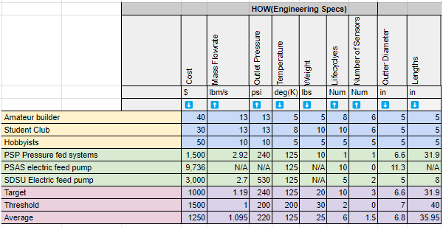

**Figure 16:** Engineering Specifications and Constraints

Having completed the House of Quality, the team evaluated that competitors mostly met goals on weight, material reliability, and cryogenic capabilities. The team aims to maintain these standards set by competitors but improve on mass flow rate, meeting required pressures as well as being cost-efficient. These goals and targets are specifically selected to fulfill the requirements of the target demographic which are college students and hobbyists that need an efficient, reliable fuel pump that fits within their price range. There have been no updates to the engineering requirements throughout the critical design phase.

**H. CAD**

***Mechanical CAD***

The overall mechanical CAD can be divided into two main sections, CAD of the core pump, magnetic coupler, and motor components, as well as the CAD of the test system and related support structure.

The CAD of the internal pump components including both the impeller and volute were initially created using CFTurbo, and exported to OnShape. A two-piece pump housing was then created around the impeller using OnShape. While all pump components were designed by the team, it is expected that the parts will be metal 3D printed from an external supplier, custom made to the given specifications. The magnetic coupler, which allows for a contact-free connection between the pump and motor shaft using a series of strong magnets, will be manufactured in house, due to both inadequate market availability and cost constraints. A brushless DC disk motor rotor will be used to hold neodymium magnets on both sides of the coupler, which will then be fastened to a metal rotor shaft. The motor which drives the system will also be purchased from an external supplier, as after revising our initial pump calculations, it was found that our existing motor could not meet the high RPM and power requirements needed for adequate performance.

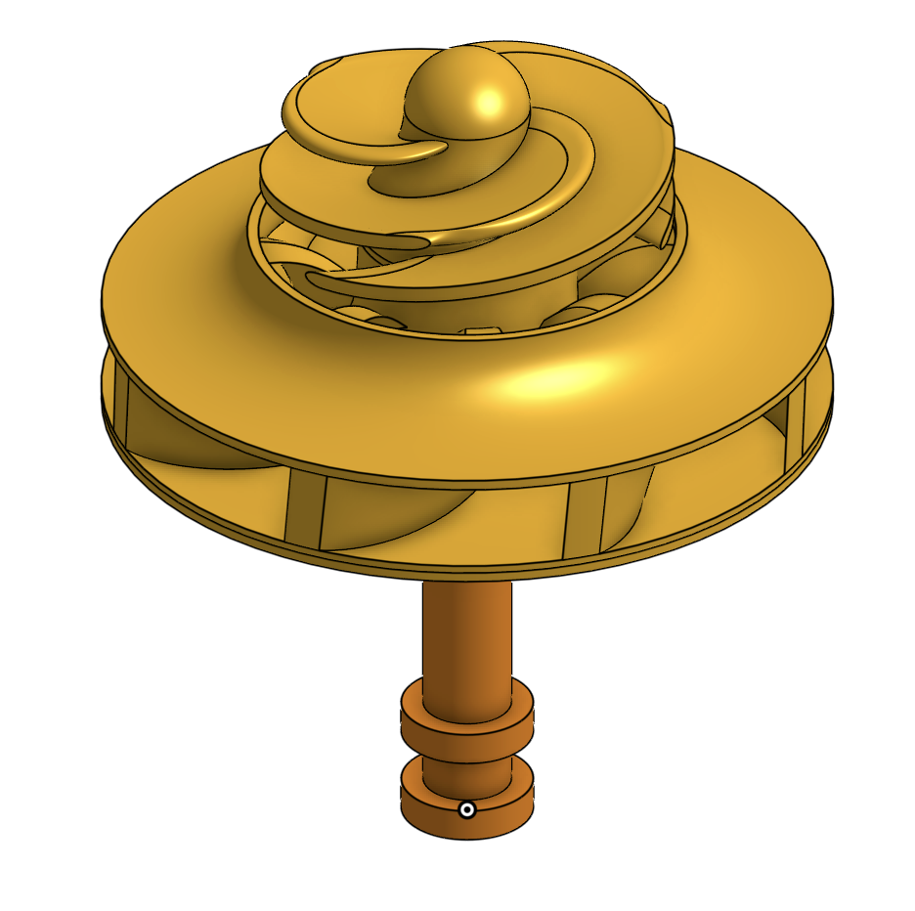

**Figure 17**: CAD Model of Internal Pump Components

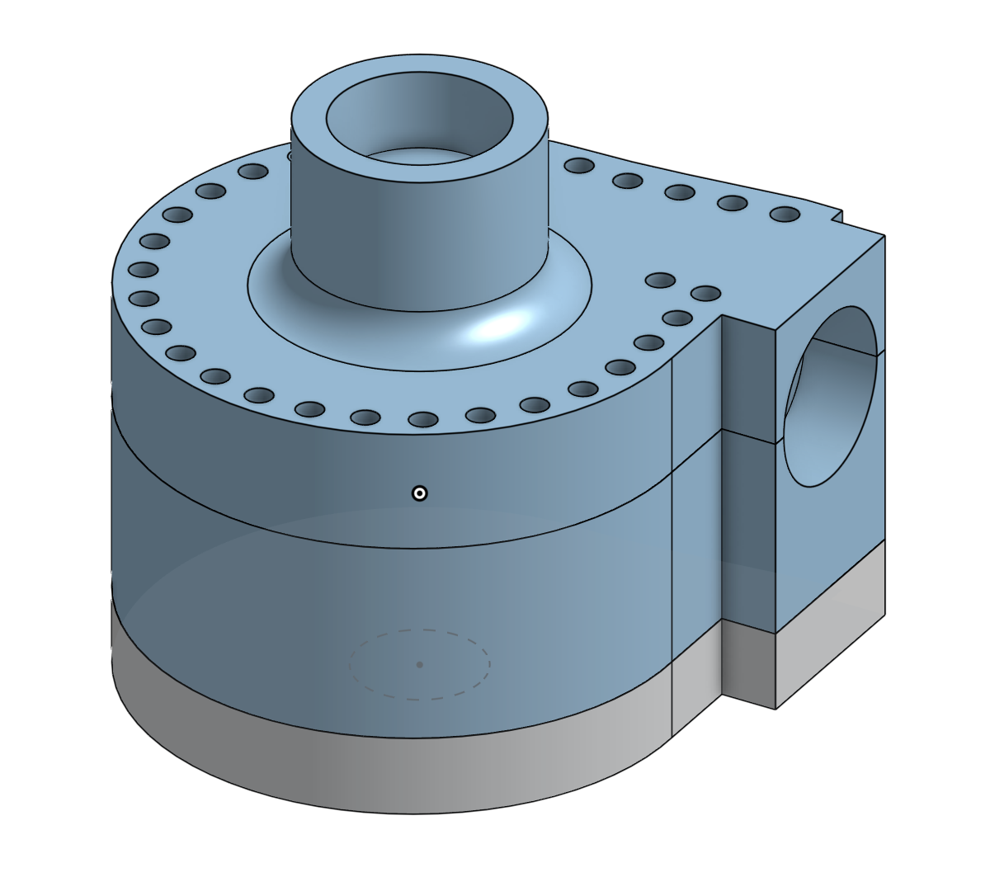

**Figure 18**: CAD Model of Pump Casing

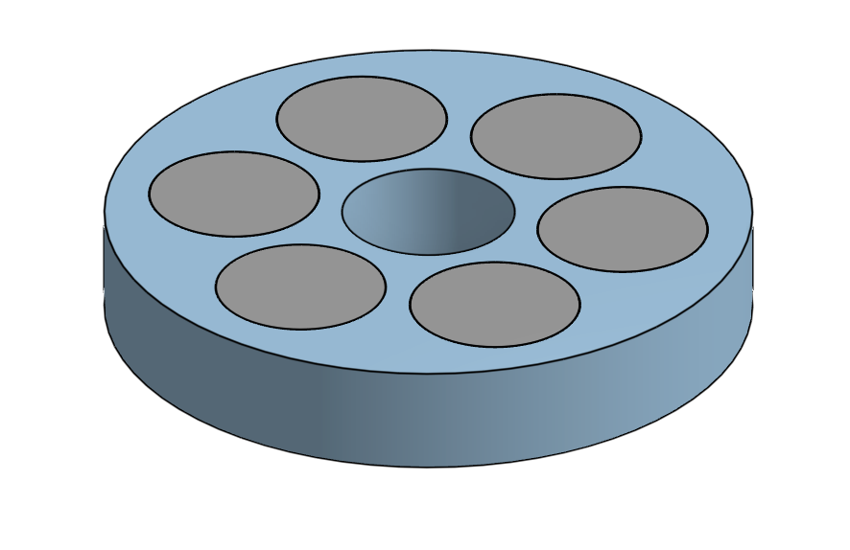

**Figure 19**: CAD Model of Magnetic Coupler

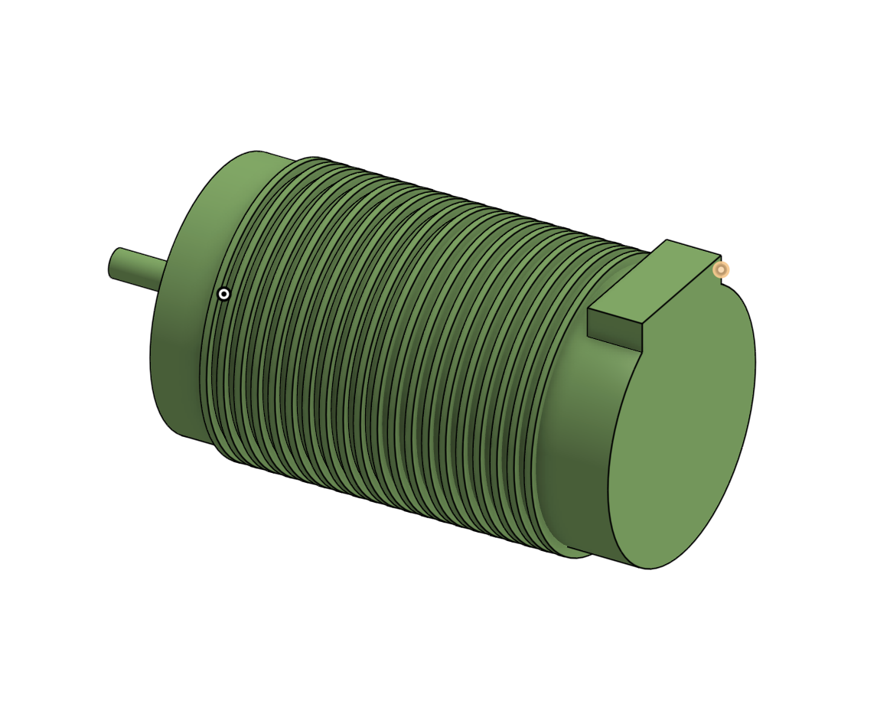

**Figure 20**: CAD Model of Motor



**Figure 21**: Final CDR CAD model of Pump System

The CAD of the test system was also created using OnShape, using the expected size of the completed pump system as a basis for the design. The test system features an integrated liquid storage tank to allow for the pump to receive uninterrupted fluid flow throughout its runtime (approximately 10 seconds), as well as adjustable platforms and a modular support system to allow for potential different sizes of the different components. The liquid supply tank is expected to be a reused and modified keg or similar container, which allows for cryo-resistance, and is planned to be obtained without purchase. The four primary support columns are expected to be made of 8020 galvanized steel signpost or a similar material, and are planned to be obtained without purchase. The remaining components, including the support platforms, brackets, bolts, and screws, are also expected to be obtained without purchase, from available material in both the machine shop and ME 463 lab areas, as well as existing materials already held by the team.



**Figure 22**: CAD Model of Pump Test System

***Electric Circuit***

For the final prototype, electrical circuits were designed to fulfill three main functions: control and power the brushless motor, get measurements from the different sensors and allow automatic emergency shutoff.

The electric motor the team plans to build (reference in BOM) is controlled by its own built-in controller and powered by a purchased 62V battery. A battery was favored over a power supply for testing since the motor requires a high voltage of 33.6V and can go up to 3000W, values that some batteries can reach for relatively cheap. On the contrary, power supplies that could fulfill these requirements can be very expensive and such power supplies require special outlets.

An Arduino card connected to a computer and with a loaded code will be used for the final design to obtain data from the different sensors. The total number of sensors will be 5: one tachometer, two type T thermocouple and two pressure meters. Each sensor is pre-owned and will be connected to the Arduino card. To obtain relevant and accurate values from the sensors, linear regression calibration will be performed for each sensor to determine the best calibration fit between the voltage and the measured variables. Using the best calibration curves from the sensors, the Arduino connected to a computer will display the variables measured in real time and will trigger the automatic emergency shutoff critical if thresholds are detected. A P&ID diagram of the simplified electrical and fluid circuit is shown below in Figure 23

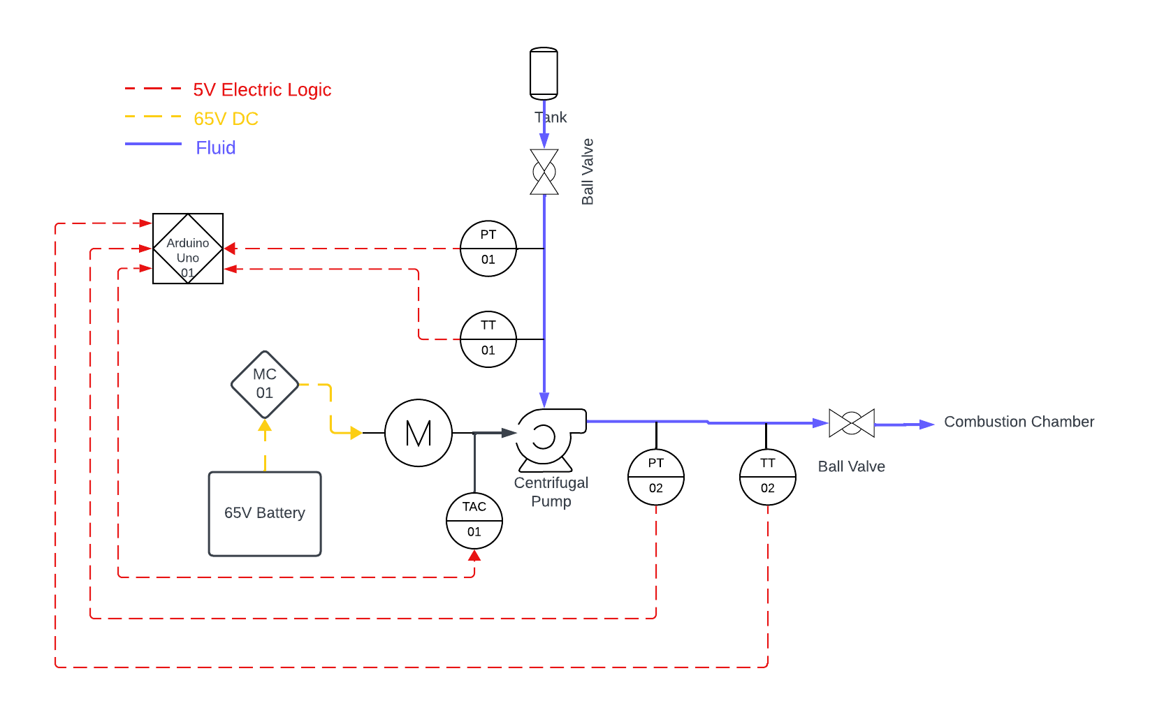

**Figure 23:** Piping and Instrumentation Diagram

**I. Analysis**

***Pump Selection Calculations:***

To create an initial understanding of the model the team chose to reference reliable sources such as past NASA textbooks as well as similar projects taken on by senior design teams over the past couple years. The team researched the complicated models of different pump designs and the principals based on which they ran. Based on goals and priorities the team set early on when analyzing the target market the team used textbooks to understand different pumps and the benefits of different designs. The team settles on a centrifugal pump design due to its reliable design when compared to a positive displacement pump as they contain fewer moving parts, with no check valves and lower pressure pulsations. Centrifugal pumps are also known for their capabilities to handle high pressures efficiently as well as economically in terms of weight and size.

The team further chose to use an axial inducer to the eye of the impeller. This addition helps raise pressure and addresses the risk of cavitation at the blades. Having completed this research the team then completed hand calculations to find the expected efficiency, specific speed, NPSHa and NPSHR. These calculations helped the team set expectations for pump performance but also set up the model in CF Turbo and CFD.

Table 03 - Pump Specifications0

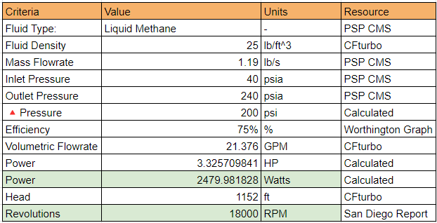

***Impeller-Housing Cryogenic Tolerancing Calculation:***

*Problem:* Need to verify that the pump housing will not shrink more than the impeller and bind when exposed to cryogenic temperatures.

*Assumptions:* cryogenic temperature is constant, lumped capacitance analysis is valid, fluid exposure is instantaneous, surrounding convection is negligent, radiation is negligent.

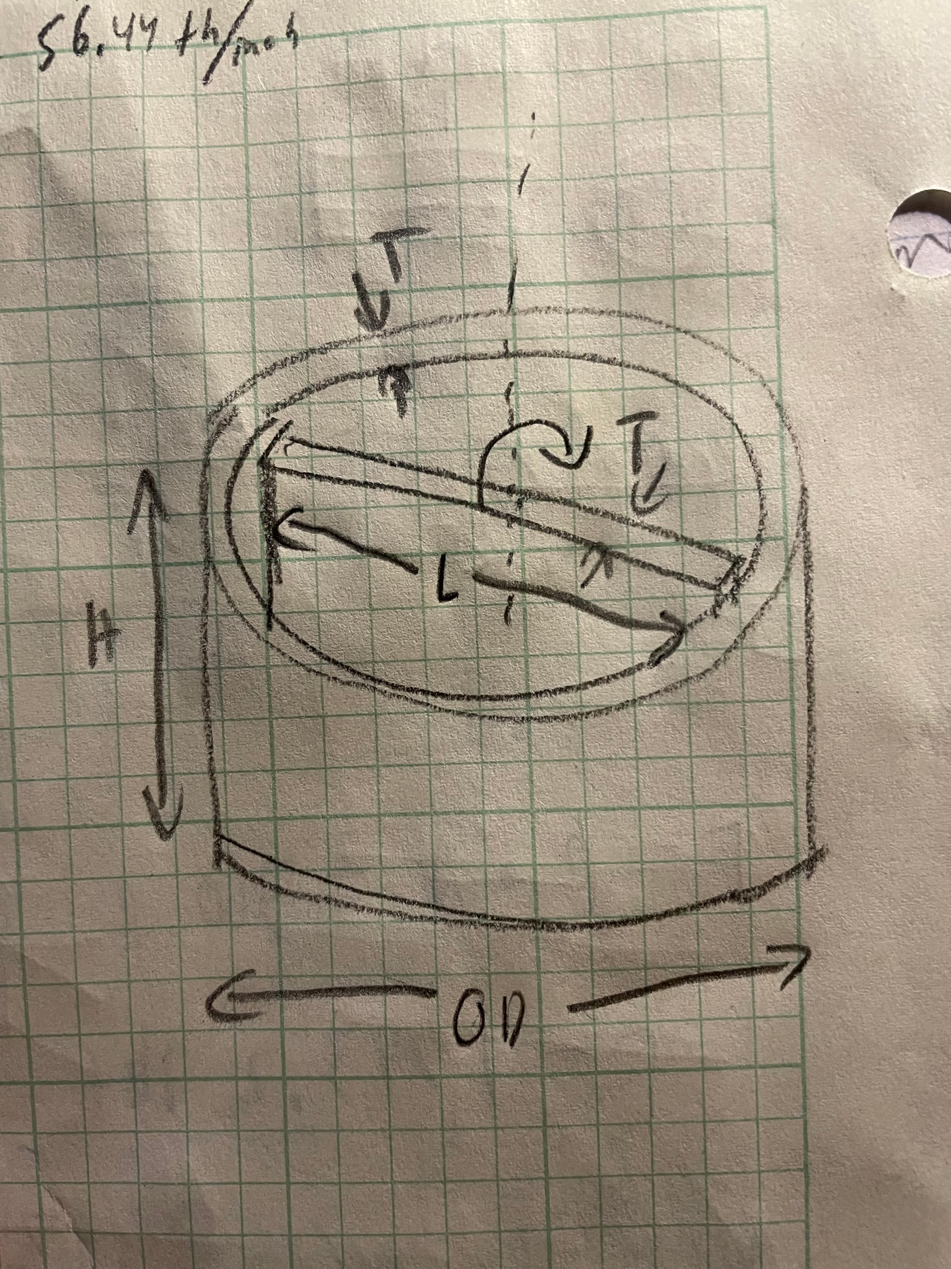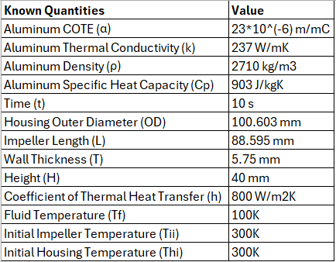

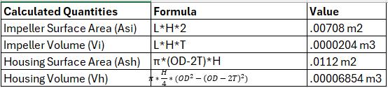

*Biot Numbers: $Bi = \frac{h*L_{c}}{k}=\frac{h*V/A_{s}}{k}$*

${Bi}_{impeller}=\frac{800*V_{i}/A_{si}}{237}$ = .0097 ${Bi}_{housing}=$ $\frac{800*V_{h}/A_{sh}}{237}$ = .0206

***-Lumped Capacitance analysis is valid, Bi < .1***

$\frac{T-Tf}{T_{i}-Tf}=e^{-\frac{thA_{s}}{ρVC_{p}}}$

Housing: $\frac{T-100K}{300K-100K}=e^{-\frac{10*800*A_{s}}{2710*V*903}}$ = .5861

**T = 217.22K**

Impeller: $\frac{T-100K}{300K-100K}=e^{-\frac{10*800*A_{s}}{2710*V*903}}$ = .32155

**T = 164.31K**

*Thermal Strain: $ε=α*ΔT$*

Housing: $ε =( c_{f}-c_{o})/c_{o}$ $c_{f}=2πr_{f}$ $c_{o}=2πr_{o}$ =.2799m $ΔT = 217.22-300K = -82.78K$

$ε=(2πr_{f}-.2799)/.2799 = 23*10^{-6}*-82.78$

$r_{f}$ = 44.466 mm ${ID}_{f}$ = **88.933 mm**

Impeller: $ε =( L_{f}-L_{o})/L_{o}$ $L_{o}=.088595m$

$ΔT = 164.31-300K = -135.69K$

$ε=(L_{f}-.088595)/.088595 = 23*10^{-6}*-135.69$

$L_{f}$**= 88.318 mm**

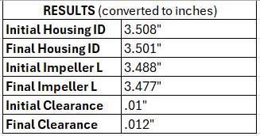

*Clearance levels will remain the same or increase so long as the impeller is designed to be as thick as or thinner than the casing. A thinner impeller means that the temperature will drop more, causing even more shrinkage and increasing the clearance. This reduces the likelihood of binding, but also decreases pump efficiency. The impeller should therefore be a similar thickness to the housing.*

***Minimum Shaft Size Calculation:***

*Problem:* With a high power motor acting on an aluminum drive shaft, the minimum shaft size must be determined to avoid failure.

*Assumptions:* motor torque on shaft is .8185 Nm and other forces (inertia, turbulence, etc.) are negligible, max shear stress occurs at the outer surface of the shaft, aluminum properties remain the same or stronger in the cold temperatures.

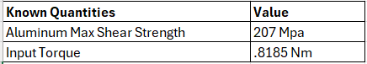

$τ=\frac{T*r}{I_{p}}$ $I_{p(circle)}=\frac{π}{32}D^{4}$

$τ≥\frac{T*D/2}{\frac{π}{32}D^{4}}$

$207*10^{6 }Pa≥\frac{.8185 Nm*16}{π*D^{3}}$

$D^{3}≥.00000002$

$D≥.0027m$ $D≥.107"$

*With a factor of safety of 1.8, the shaft diameter should always exceed .193”.*

***Bolt Number Calculation:***

*Problem:* Pressure inside the pump will be as high as 360 psi. The number of bolts used to hold the casing together must be calculated such that the bolts elongate no more than .0001”, to prevent leakage.

*Assumptions:* Pressure is a uniform 360 psi throughout the pump, bolts are sufficiently insulated to neglect cold-temperature effects, 18-8 stainless steel M2.5 bolts are used, radial pressure loads are equal around the pump walls and cancel out.

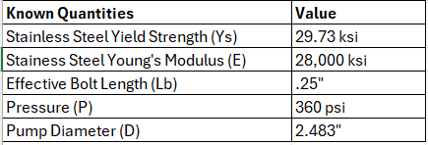 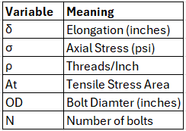

Bolt elongation formula: $δ=σ*L_{b}/E$

Bolt tensile stress area: $A_{t}=.7854*(OD-(.9743/ρ))^{2}$

For a M2.5 bolt, pitch is .45mm/thread. $\frac{.45mm}{thread}*\frac{1inch}{25.4mm}⇒56.44 threads/inch$

$A_{t }=.7854*(.0984-(.9743/56.44))^{2}=.0052 inch^{2}$

$F = P*πD^{2}/4$

$F=360psi*π*2.483^{2}/4$

F = 1743 lbf

$σ=F/A$ $A = A_{t}*N$

$σ=\frac{1743}{.0052*N}$ $σ=335192/N$

$δ= .0001"=\frac{σ*.25"}{28*10^{6}}$

$σ=11200 psi$ 11200 psi < Yield strength (27000 psi),

11200 = 335192/N **N $≃$ 30 bolts**

*The elongation requirement already imparts a factor of safety of 2.4, so no extras are needed. 30 bolts will be sufficient to contain the pump and prevent leakage. This calculation was crucial, as our original design only used 10 bolts.*

***Fluid Dynamics Simulations:***

In combination with the pump calculations and CFTurbo, a CFD simulation was created and ran to verify the calculations done. The workflow created in Ansys workbench can be seen in figure 24.

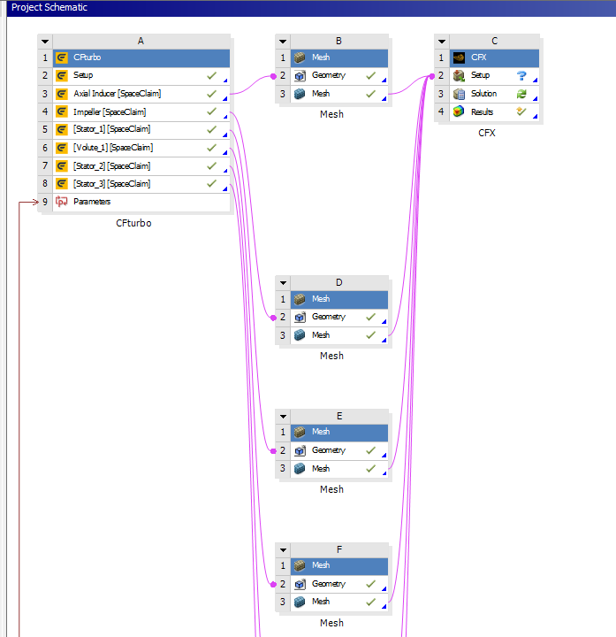

**Figure 24:** Ansys workbench simulation workflow

The first step in the workflow was to import the geometry from CFTurbo using space claim. This allows for a separate fluid domain to be created for each part of the pump. From there each part was separately meshed using Ansys meshing. A minimum mesh size was chosen based on the size of the overall geometry. The total simulation domain has a volume of around a 1 in^3 so a maximum element size of 1*10^-4 in^3 was chosen to allow for the elements to be small enough for the solution to converge properly. A basic mesh spacing was used on inlet and outlet domains, but for the other domains and inflation mesh was used. The inflation mesh adds a boundary layer to the mesh which is important for capturing the boundary layer which will form in the flow. This inflation mesh also adds more mesh elements at the fine corners and edges of the domain which will need the smaller elements for proper convergence. Figure 25 shows the mesh for the axial impeller. It demonstrates the meshing methods mentioned above.

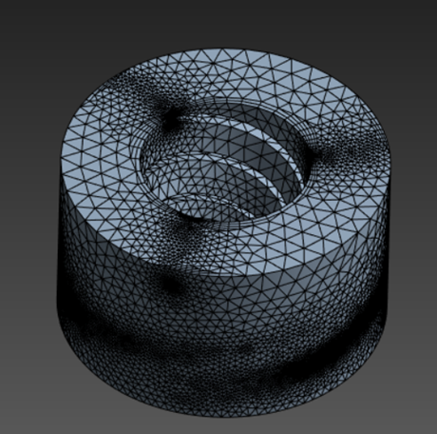

**Figure 25:** Mesh for the axial impeller in Ansys Mesh

The bigger elements where not much of interest is happening in the flow are limited by the maximum mesh size. There is a small boundary layer visible around the center opening. The mesh is refined on both the top and edges where the blades hit the edge of the domain and is visible where the dark spots of the mesh are. All domains in the simulation were meshed in a similar fashion to this one.

After the mesh for each element was created they were imported into CFX for simulation. Due to how the geometry is imported the domains import into their correct respective locations already. First inlet and outlet conditions are specified. It can be seen that extensions have been attached to the outlet and inlet, this is to help with the convergence of the solution as this is likely how the pump will be functioning in reality. The inlet is a pressure inlet at 40 psi as specified by PSP’s pressure inlet for the pressure driven flow method. The outlet is a mass flow outlet at 1.19 lbm/s as that is the target mass flow rate for the pump. The boundary conditions for the rest of the domains are then specified. The stationary walls are set as stationary and the rotating domains, mainly the impeller and axial inducer, are set to rotate at 35000 rpm. Between the domains interfaces are set up. For the interfaces between stationary domains it is just a simple interface connection. For the domains where one is rotating and one is stationary a frozen rotor method is used. This method allows for the rotation to still have the correct impact on the fluid in the domain that is rotating without affecting the domain that is stationary. Figure 26 shows this final setup of the simulation.

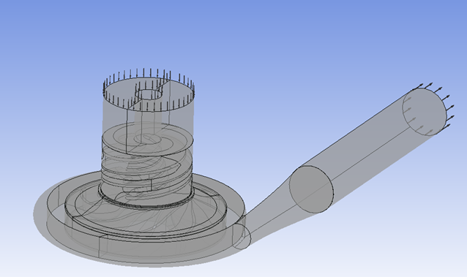

**Figure 26:** Flow domain setup in CFX-Pre

After the boundary conditions are set the solver controls are specified. The residuals are aimed to converge to 1e-04 and the max iterations is set to 1000 as if it gets to that point without convergence it will likely never converge. Figure 27 shows the residuals converging for the simulation.

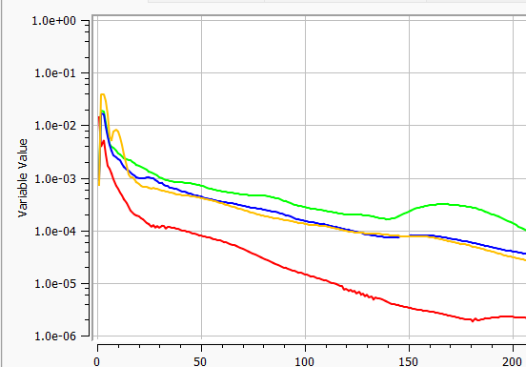

**Figure 27:** Residuals vs. iteration for the simulation

The simulation converged after around 1 hour and 225 iterations. After the initial simulation it was realized the pump was not performing well enough and the team decided to add a back flow region into the impeller. Figure 28 shows that backflow region.

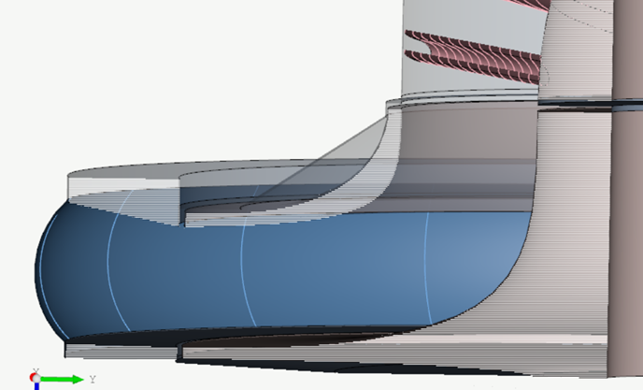

**Figure 28:** CFTurbo 3D model with backflow region

The backflow region is the linear gray portion above the shroud of the impeller. After adding the backflow region and repeating all the steps again as specified a final simulation was performed. Figure 29 shows the results of that final simulation.



**Figure 29:** CFX post results of final simulation

It can be seen that the final pressure is around 1.87e6 Pa or 275 psi. This is above the design requirement of 240 psi so the team was satisfied with the results of the simulation. It can also be seen that in the impeller region the pressure does not drop below the vapor pressure of methane at -235 F. This means that the pump will not cavitate under the operating conditions which is satisfactory to fulfill that requirement.

**J. FMEA**

In order to identify the critical component of the project that needed to have some analysis performed on them a failure modes and effects analysis(FMEA) was created. The FMEA was created to serve as a guide for the team on what aspects of the design needed engineering analysis performed on them and which design aspects specifically were most critical for the project's design. To begin all the potential failure modes were identified through a team brainstorming session. The failure mode identification can be seen in figure 30.

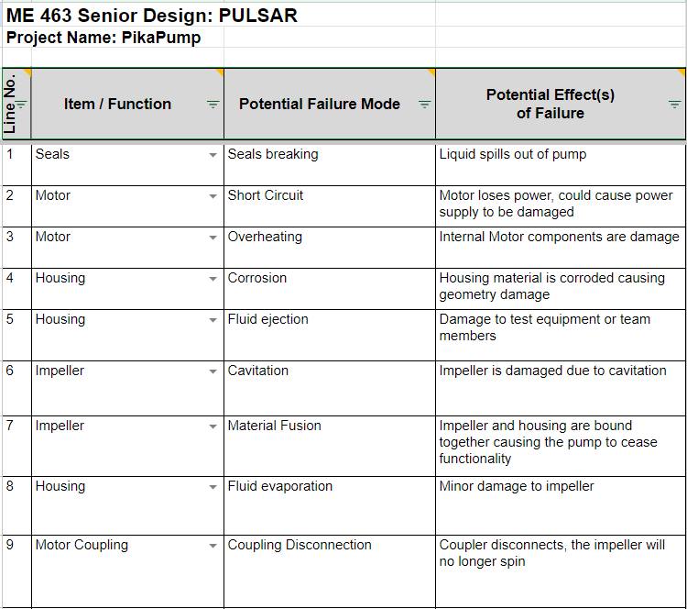

**Figure 30:** Failure mode identification section of the FMEA

Once the failure modes were identified they were all ranked based on three different criteria. Those being severity, occurrence, and detectability. Severity describes the damage done to the project with 1 being no effect and 10 being complete destruction of a critical component the pump. Occurrence ranks how frequently this risk is to occur with 1 being never and 10 being every time the pump runs. Detectability ranks how easy the failure will be to detect with 1 being the design will reliably detect the failure every time and 10 being no possibility to detect the failure until it is too late. Figure 31 shows the rankings for each corresponding failure mode.

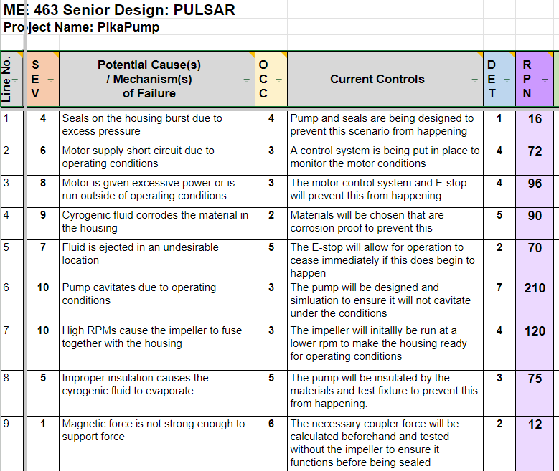

**Figure 31:** Failure mode ranking section of FMEA

The team used these rankings to determine where to spend more time in the critical design phase. The failure modes with a higher risk priority number (RPN) were addressed first. The highest being the potential cavitation of the impeller, the fusing of the impeller to to housing, the motor overheating, and the materials of the housing corroding. As a result these aspects of design were where the team spent most of their time. CFD was performed on the pump geometry and other hand calculations were performed on the motor and materials in order to ensure these failure modes do not occur.

After performing the engineering analysis the failure modes were reassessed with the necessary mitigation actions reported in the FMEA. The team has decided after this reassessment that all of the failure modes have been satisfactorily addressed and the project will be able to move into the manufacturing and testing phase without any critical failures. The reassessment can be seen in figure 32.

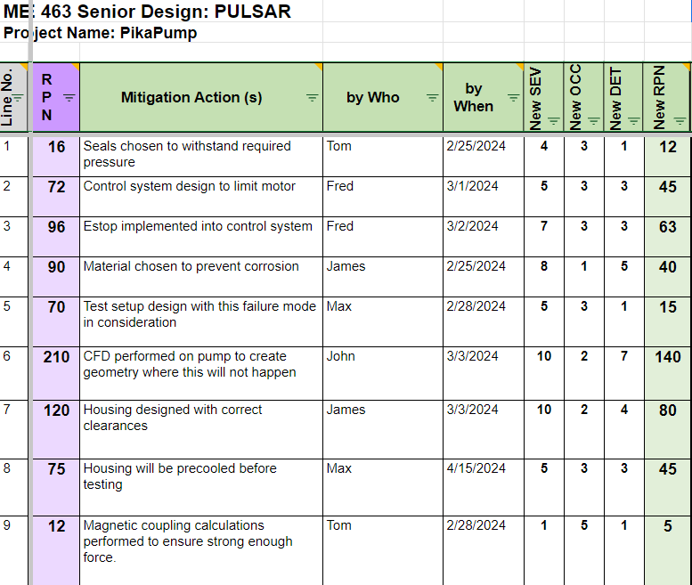

**Figure 32:** Mitigation section of the FMEA

Some of the failure modes have relatively higher scores due to the higher severity. The team will continue to monitor these as the project continues so the failure can be detected and prevented. The FMEA will continue to be monitored and updated in the final design phase so the team can attempt to prevent failure of any of the design components.

**K. BOM and Sourcing Plan**

The Bill of Materials is as complete as can be anticipated at this stage of the design. A full system has been designed and all of the machined parts, fasteners, seals, and small items have been accounted for. The final budget is slightly under the $1000 limit, but this is to account for extra shipping costs and parts that may be needed later on after design iteration. The source of each of the components has been attached as well as if the team will need to “make” or buy the part. The sources are fairly diverse since the project will require parts such as seals, bearings, electronics, motors or some metal material to be machined or 3D printed in stainless steel. Some parts are listed as “Pre-owned”, meaning that the team already possesses these parts and no sourcing plan is needed for them. Conventional machining will be done in the ME Student Project Machine Shop and the CNC work will be done in the same location with the help of John Wheeler or in the Manufacturing and Metrology Lab with the help of Kyle Baer, depending on availability. Stock aluminum is to be purchased online via Metals Depot or sourced from the stock room or other scrap locations on campus.

**Table 04**: Bill Of Materials

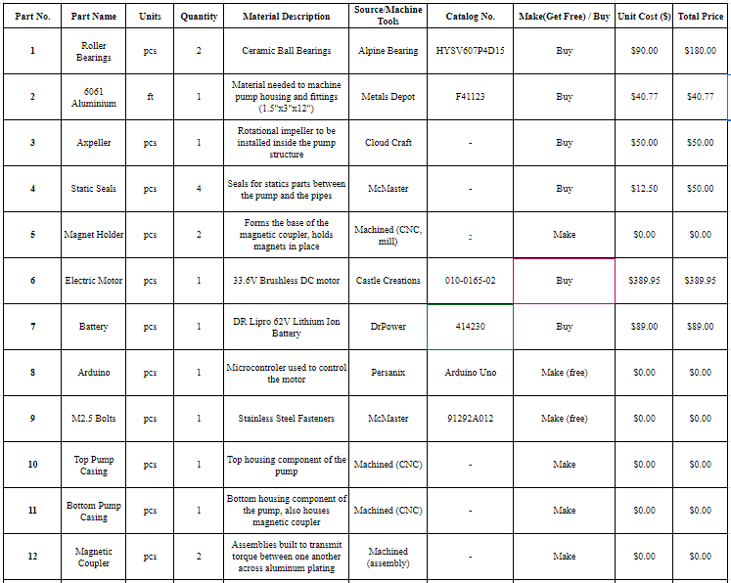

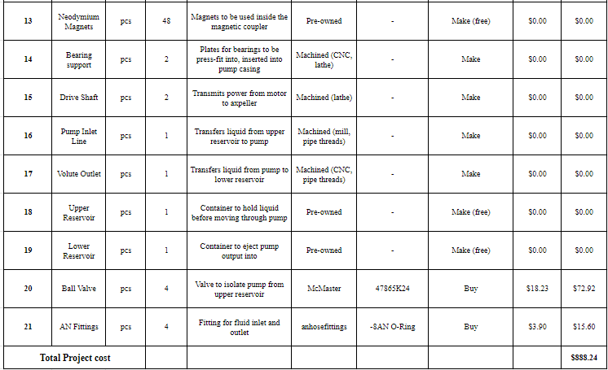

**L. Validation Plan**

The primary goal of the project is to design, build, and test an electric pump that could feed cryogenic liquid propellants at sufficient pressures and mass flow rates into a combustion chamber. Due to timing and Zucrow test stand availability, it is unlikely that the team will be able to do a full cryogenic test of the system, therefore, following industry standards, PULSAR will be testing the PikaPump using liquid water.

To assist in understanding the validation a CFD simulation with water instead of methane was performed. The pressure, rotational speed, and outlet conditions were kept the same as the cryogenic simulation as that will be the conditions of the test. However, the temperature and fluid properties were changed to make the simulation more accurate to the test conditions. The simulation took much longer to converge, but in the end still was able to attain good results. Figure 33 shows the results of this simulation.

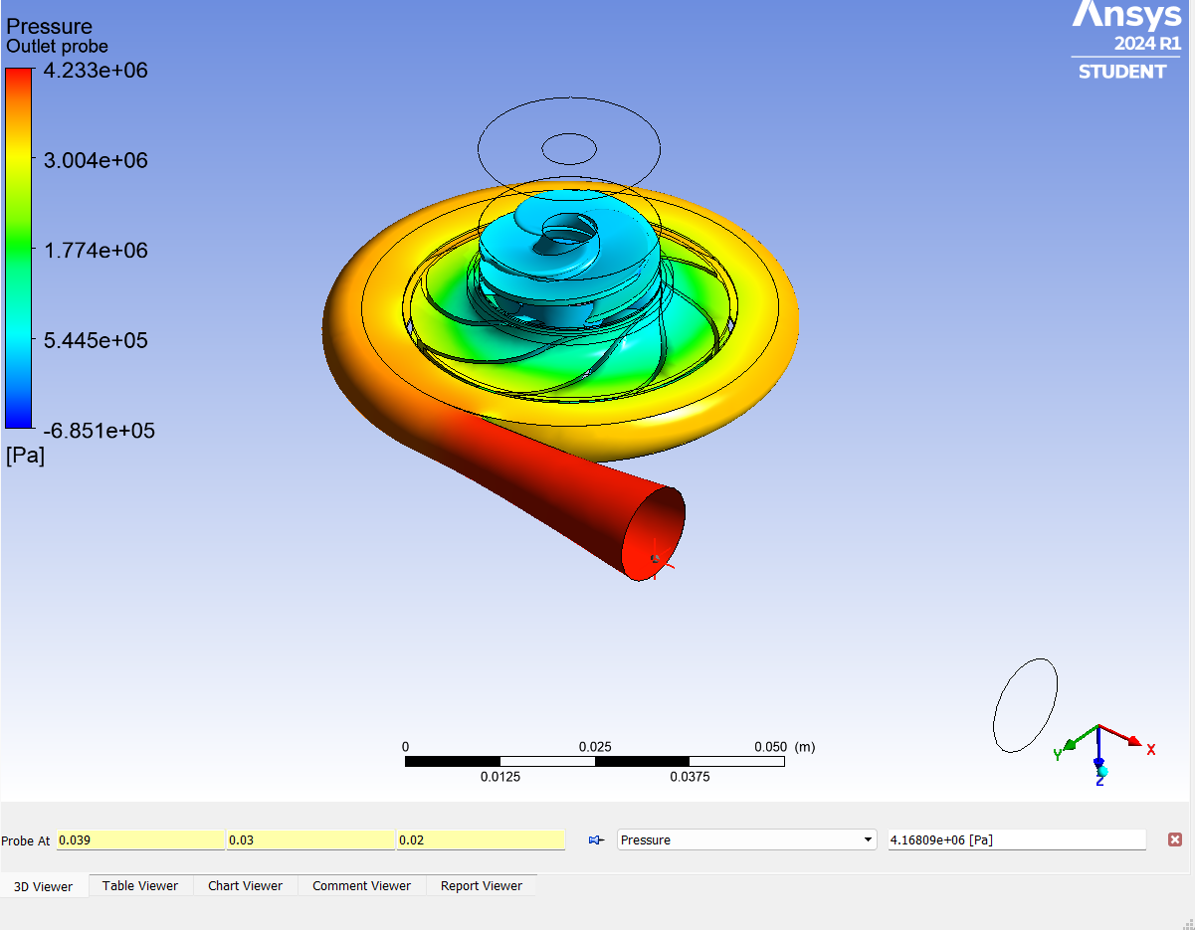

**Figure 33:** CFX-Post of simulation with Water

It can be seen that the pressure resulting is much higher than with the cryogenic fluid which is expected due to the properties of water. The outlet pressure is expected at around 4.168e06 Pa or 605 psi. Due to this high pressure, the team has decided when testing to start running it at a lower rpm value to ensure all the functions, primarily the seals and fittings function properly. From there the team will step up the rpm until reaching operating conditions.

Moving forward the team worked to finalize the testing plan for the system. To model and test the system the team chose to use water as a test liquid followed by liquid nitrogen to then check temperature resistance. The goal here is to safely test for leaks and interference without the safety risk of the highly flammable nature of liquid methane. Water has been chosen as a substitute as it is almost as vicious as liquid methane [0.000176 Pa s (Methane) vs 0.001 Pa s (Water)] and thus mimics liquid methane well when testing for friction losses throughout the pump.

Additionally, the team went on to model the test setup for the validation plan. The team designed the organizational components and researched the sensors as well as the data acquisition system that would then be used to verify expectations and quantify results. This new information regarding the acquisition system available to students allowed the team to finalize the choice between the Arduino vs the Raspberry pie for data collection. The team chose to go with an Arduino uno card for Data acquisition and system monitoring since it allows analog and digital inputs from the different sensors. The Arduino card connected to a laptop and wired to the sensors allows for real-time display of different measured variables and can trigger automatic emergency shutoff if needed. Having finalized this plan the team drew and finally modeled the test plan using Onshape as shown below.



**Figure 34**: CAD Model of Pump Test System

Based on the designed model and test set the team also drafted a high-level test plan which included the sequence of steps required to accurately collect data and calibrate sensors to avoid errors. The team went on to then organize a list of deliverables to ensure that all required data was collected to accurately judge and summarize pump performance and isolate issues if any. The team test takeaways include but are not limited to testing the pump fitting and interferences and checking for obstructions, checking for smooth rotation of the magnetic coupler with maximized torque, and least loss of RPMs during translation. The team slo plans to prioritize spills and containment, for best pump efficiency any loss of pressure unaccounted for has larger implications on performance but furthermore on safety risks when using Liquid methane. Apart from these the team also plans to use pressure probes and temperature probes to best understand the working conditions of the pump and derive realistic correlations between pump performance and working conditions. These data collection methods will also contribute to evaluating the pump performance when compared to preset targets established during the preliminary design review.

**Appendix 4 - Works Cited**

*Bolt elongation equation and calculator while under axial stress*. Engineers Edge - Engineering, Design and Manufacturing Solutions. https://www.engineersedge.com/calculators/bolt_elongation_14608.htm

*Circular ring - temperature expansion*. Engineering ToolBox. (n.d.). https://www.engineeringtoolbox.com/thin-circular-ring-radius-temperature-change-d_1612.html

Goodrich, C. (2021) *Performance testing of centrifugal pumps, Pumps and Systems Magazine*. Available at: https://www.pumpsandsystems.com/performance-testing-centrifugal-pumps (Accessed: 06 February 2024).

Huang, D., & Huzel, D. (n.d.). *Design of liquid propellant rocket engines, second edition - NASA technical reports server (NTRS)*. NASA. https://ntrs.nasa.gov/citations/19710019929

Larrin. (2019, January 7). *Why cold steel is brittle*. Knife Steel Nerds. https://knifesteelnerds.com/2018/12/21/why-cold-steel-is-brittle/

Rocket Engine Turbopump With Coolant Passage In Impeller Central Hub. (2022, August 9).